

2026 Board Candidate Information Pack

Contents
Contents 1
Introduction 1
Role overview 1
Board composition and responsibilities 1
Eligibility to nominate or be nominated 3
The Election 5
Social Media 7
Self-Hosted Events 7
How does the election system work? 8
Useful links 9
Useful contacts 9
Appendix A: Self-assessment of skills and diversity by current Board members 10
Summary 10
Governance 11
Specialist areas 13
Diversity attributes 15

Introduction
This pack provides key information and useful links to help potential candidates prepare for the upcoming 2026 InternetNZ Board elections.
For further questions/pātai, please email: election@internetnz.net.nz

Role overview
The Board is the governing body of the InternetNZ Society. Under the provisions of the new Constitution, the Board should ideally consist of nine members, but must always have no fewer than seven. Board members must act in good faith and in the best interests of the society at all times.

Board composition and responsibilities
Following the 2026 AGM, the InternetNZ Board will be made up of nine members:
- 7 Elected Board Members, who must be Eligible Members of the Society; and
- 2 Appointed Board Members.
The Board sets InternetNZ’s strategic direction and provides oversight. The Board holds ultimate responsibility for the governance and direction of the InternetNZ Group. InternetNZ’s management and staff carry out the operational work under the direction of the Tumu Whakarae | Chief Executive, including implementing the strategy, day-to-day operations, and managing staff, budgets and risk.
Examples of Board responsibilities include:
- Ensuring InternetNZ meets its national and international obligations for running the .nz domain and Domain Name System;
- Setting and monitoring the organisation’s strategic direction;
- Approving the annual budget envelope and annual goals;
- Appointing, supporting, and holding the Tumu Whakarae | Chief Executive to account;
- Acting as stewards overseeing InternetNZ’s ownership role in the Domain Name Commission (DNC).
Board members will receive a payment for their service, and InternetNZ covers any necessary meeting and travel expenses.

Who should consider standing for the Board?
Eligible Members who have the skills, experience, perspectives, and time to support our kaupapa (purpose) are encouraged to consider standing for a position on the InternetNZ Board.

Expected time commitments
Before standing, candidates should ensure they are willing and able to commit the time required for the full term of the role.
Board members are expected to commit, in aggregate, approximately two days per month to Board-related activities. This includes:
- At least four full-day Board meetings each year, in person at InternetNZ's office in Te Whanganaui-a-Tara Wellington (occasional online attendance is possible, however in-person attendance is highly preferred).
- Additional in-person or online Board meetings, if required, as well as online Board pop-up sessions when necessary to address specific issues or matters arising.
- At least four Board sub-committee meetings each year (1.5 to 2 hours), usually held online.
- Training sessions, strategic workshops, organisational development and other events or meetings.
- Engaging in Board communications by email and other mediums as necessary.
- Preparation for meetings, including reading papers, reviewing minutes and action points as assigned.
Scheduled Board meetings and events for the remainder of 2026 include:
- September 10, 2026 — New Board member induction and strategy day. (In-person, Wellington)
- September 11, 2026 — Board meeting. (In-person, Wellington)
- November 26, 2026 — Board business development strategy day. (In-person, Wellington)
- November 27, 2026 — Board meeting. (In-person, Wellington)
Board members are expected to be available for all scheduled Board meetings from 9:00 AM to 5:00 PM in Wellington.
Board members are also encouraged to:
- Attend and participate in InternetNZ events throughout the year.
- Join and contribute to member spaces, including the members-discuss email list, and our community platform, NetHub.
For more information on the roles and responsibilities of the Board, please refer to the InternetNZ Constitution, Board Charter and Board Bylaws.

Eligibility to nominate or be nominated
Under clause 3.8.2 of the InternetNZ Constitution, any Eligible Member of the Society may stand for election, provided they meet:
- the qualification requirements in clause 3.5, and
- the maximum term requirements in clause 3.9.2.
To be eligible, a person must be an Eligible Member on or before the date the Nomination Period closes.
The Nomination Period refers to the timeframe during which nominations are open, as outlined in clause 3.8 of the Constitution.
Eligible Members may nominate themselves, or another Eligible Member to stand as a candidate.

How do I nominate another Eligible Member?
Any Eligible Member can nominate another Eligible Member using the official 2026 candidate nomination form.
Once a nomination form is submitted:
- You will automatically receive an acknowledgement.
- The nominated person will be contacted by the Returning Officer by email or phone to:
  - Confirm whether they wish to accept the nomination
  - Answer any questions they may have about the process.

What happens if I am nominated?
If another Eligible Member nominates you, the Returning Officer will contact you directly via email and phone. This is your opportunity to ask any questions about the process.
Nominations will only be accepted once the nominee has confirmed, either verbally or in writing, their willingness to stand for election.
If a candidate decides to withdraw after voting has opened, their name will remain on the ballot but will be marked as “withdrawn”. Under the STV voting system, any preferences for that candidate will automatically transfer to the voter’s next ranked choice. Votes already cast cannot be changed or reissued, in order to maintain the integrity of the election process.
What if I don’t have someone to nominate me?
Under clause 3.8.3 of the Constitution, Eligible Members may self-nominate or be nominated by another Eligible Member to stand as a candidate for election.
If you are interested in standing for election and have questions about the nomination process, the Returning Officer can provide guidance on the election process and next steps. The Returning Officer will contact candidates by email and phone to confirm their interest in standing and to support them through the nomination process (as outlined below).

Who is ineligible to be a Board Member?

You are not eligible to be a Board Member if:
- You do not meet the qualification requirements in clause 3.5 of the Constitution.
- You have already served as a Board Member for the maximum term of 9 years, as in clause 3.9.2.
- You are disqualified from being appointed or holding office as an officer of the Society under either:
- Section 47(3) of the Incorporated Societies Act or
- Section 36B of the Charities Act
Clause 3.5.3 of the Constitution provides full details.

Confirmation of candidacy
Candidate names will be published with a “pending” status until all required candidate materials have been received and acknowledged by the Returning Officer.
- Confirmation in writing that you are willing to serve as an Officer as defined in section 47 and 54 to 60 of the Incorporated Societies Act.
- Confirmation that you are not disqualified under section 47(3) of the Incorporated Societies Act or section 36B of the Charities Act.
- Confirmation that you meet the qualification requirements (clause 3.5) and maximum term requirements (clause 3.9.2).
- A recent photograph.
- Written responses to these two questions (max 500 words total)
1. Why are you interested in being a Board member for InternetNZ?
2. What skills and experience will you bring to the role?
- (Optional) A short video (max 5 minutes) outlining what you hope to contribute and the value you will bring to the role, if elected.

Once you are confirmed as a candidate:
- Your photo, written responses, and video will be published on the InternetNZ website (via YouTube).
- All candidate information will be released simultaneously once all candidate information has been received.
- You will receive an email confirming your information has been uploaded.
Please note: Once your material is published on the website, no further changes will be made.

Candidate announcements
Each week during the nomination period, InternetNZ will announce the names of confirmed candidates via:
- The NetHub community platform
- The members-announce mail list
The full candidate information (biographies, photos and videos) will be released once the nomination process has concluded.

The Election

Returning Officer
The Returning Officer is responsible for running a fair and effective election process that upholds the InternetNZ Code of Conduct.
Appointed by the Board, the Returning Officer acts in a neutral capacity. Their role includes:
- Communicating to Members about the current knowledge, skills and experience needed for the Board
- Encouraging Eligible Members to nominate themselves or others
- Supporting the annual InternetNZ Board elections
- Being the main point of contact for candidate questions
- Building and maintaining positive relationships with candidates throughout the process
- Providing feedback to the Board and to the InternetNZ membership team
- To ensure that appropriate conduct is maintained

Candidate Obligations over the election period
All confirmed candidates are expected to:
- Agree to abide by the InternetNZ Code of Conduct.
- Participate respectfully and constructively with each other, and with Members, throughout the election process.
When nominated, Board Candidates will:
- Undergo a Police check
- Complete other formalities legally required as governors of an Incorporated Society, such as Conflicts of Interest declaration.

Key dates
For the 2026 election, the key dates are:
- Nomination period:
  - Opens 9 am, Thursday, 11 June 2026
  - Closes 5 pm, Thursday, 16 July 2026
- Voting period:
  - Opens 12 pm, Friday 24 July 2026
  - Closes 12 pm, Monday 10 August 2026.
Where can Members discuss the Election and Campaign?
Campaigning is welcome during the official election period (voting and nomination periods). Candidates may:
- Discuss the election
- Share campaign materials (e.g. posts, images, written content)
- Encourage votes for or against any candidate.
Any campaigning must adhere to the InternetNZ Code of Conduct. The incumbent Chair and Deputy Chair commit to ensuring a respectful, inclusive election process. To support this, moderation will be provided in InternetNZ-managed spaces as needed.
- InternetNZ hosts NetHub, a Slack-based community platform for members. Candidates are welcome to use NetHub to engage and campaign respectfully.
- Candidates may also campaign on their own platforms (e.g., websites and social media). Note that InternetNZ is not responsible for moderating external spaces.

NetHub’s Members chat ‘2026 AGM’
- This is an open Slack channel in our online member community.
- Members must opt in to access the channel.
- Campaign-related messages in this space will be moderated by InternetNZ staff and Board.
- All communications are subject to InternetNZ’s Code of Conduct.
- If you don’t currently have access to the members-chat channel, please contact membership@internetnz.net.nz

‘About the Candidate’ videos
- InternetNZ encourages each candidate to record and share a short video (up to 5 minutes in length), which will be hosted on the website (via YouTube) for voters to review.
- We encourage candidates to use these videos to express to voters why they believe they should be on the Board.
- Further guidance on these videos will be provided to candidates.

‘Meet the Candidates’ sessions
- InternetNZ will look to host two online “Meet the Candidates” webinar sessions during the election voting period.
- These sessions will be scheduled on the following dates and times to provide further opportunities for members to engage with nominees before voting closes.
  - Wednesday, 29 July 5.30pm - 7.00pm
  - Tuesday, 04 August 12.30pm - 2.00pm
- We reserve the right to not run this event for any reason.

Campaigning on Other Channels

Social Media
- Candidates are welcome to use their own public social media accounts during the election period.
- Candidates are responsible for moderating their own content and interactions on these platforms, and in a manner consistent with the Code of Conduct.

Self-Hosted Events
- Candidates may also host their own online or in-person sessions for groups of members.
- These sessions should run in a manner consistent with the Code of Conduct.
- Candidates may include information about any self-hosted sessions in their candidate profile.
- After nominations close, InternetNZ can also share session details via the members-announce email list, which goes to all members.

Contacting members
- Candidates may contact individual members directly through any medium (e.g. direct message, email, phone, messaging system, or post) but only once per member during the election period.
- If a member feels that the contact is unwanted or inappropriate, they can report it to the Returning Officer, who will follow up directly with the candidate.

How does the election system work?

Election System
InternetNZ uses the Single-Transferable Vote (STV) system. Under this system, voters rank candidates in order of preference.
- Place a “1” next to your first choice
- A “2” next to your second choice, and so on.
We encourage all candidates to familiarise themselves with how the electoral voting system works.

Elections Provider
InternetNZ uses Electionz.com to deliver our online voting platform and election services. Electionz.com is a trusted provider that has worked with InternetNZ for several years.

Announcement of Results
- Final election results will be announced at the Annual General Meeting (AGM) on 13 August.
- Before the public announcement, the Returning Officer will contact all nominees by phone to share the results.
- In some cases, interim results may be shared, subject to confirmation following a review by an external scrutineer.
The confirmed final results will be published as the official public record in the Historic Elections section of the InternetNZ website.

Appointed Board Members
In addition to elected Board Members, InternetNZ also appoints two Board Members to ensure the Board has the appropriate spread of skills, knowledge, and experience required for effective governance.
Appointed Board Members are selected through a formal process led by an Appointments Panel. This panel makes recommendations to the Board, which then makes the final decision on appointments.
The Appointments Panel includes:
- at least one Eligible Member (who is not a Board Member or staff member)
- one current Board Member
- one independent governance recruitment expert.
When considering appointments, the Board takes into account:
- the overall skills, knowledge, and experience required on the Board
- diversity and representation, including commitments relating to Te Tiriti o Waitangi
- any gaps identified in the current Board composition.
Appointed Board Members are appointed for a three-year term. They are not required to be members of InternetNZ.
Prior to the 2026 AGM, two Appointed Board Members will be appointed for a three-year term, with their period starting from the 2026 AGM.

Useful links
- InternetNZ Constitution
- Bylaws
- Governance Charter and policies
- Board papers
- 2025 AGM Minutes
- InternetNZ voting system explained
- NetHub

Useful contacts
Returning Officer | election@internetnz.net.nz
General election enquiries | election@internetnz.net.nz
InternetNZ membership team | membership@internetnz.net.nz
Electionz | vote@electionz.com

Appendix A: Self-assessment of skills and diversity by current Board members

Summary
This report provides a refreshed assessment of the skills, experience, and diversity attributes of current Board Members who will remain on the Board following the 2026 elections.
This Skills and Diversity Assessment has been completed by the following Board Members:
- Chairperson — Stephen Judd (term ends at AGM 2027)
- Deputy Chairperson — Anjum Rahman (term ends AGM 2027)
- Richard Hulse (term ends at the AGM 2027)
- Dylan Reeve (term ends at the AGM 2028)
- Jonathan Ayling (term ends at the AGM 2028)
The following Board Members have been excluded from this report, as they are completing their term on the Board in 2026:
- Kate Pearce (term ends at the AGM 2026)
- Potaua Biasiny-Tule (term ends at AGM 2026)
- Whetū Fala (appointed, term ends 2026)
- Anthony Bow (appointed, term ends 2026)
- Daniel Spector (term ends at AGM 2026)
Members are encouraged to use this Skills and Diversity Matrix to better understand the skills, experience and diversity attributes of the current Board. This information can help inform member participation in the InternetNZ Board election process.

Governance
These are core skills and knowledge areas relevant to the Board’s role as the governing body of InternetNZ.
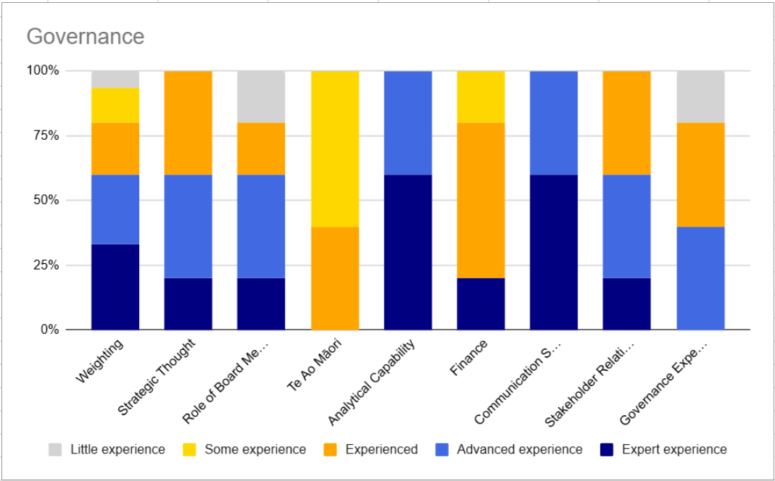
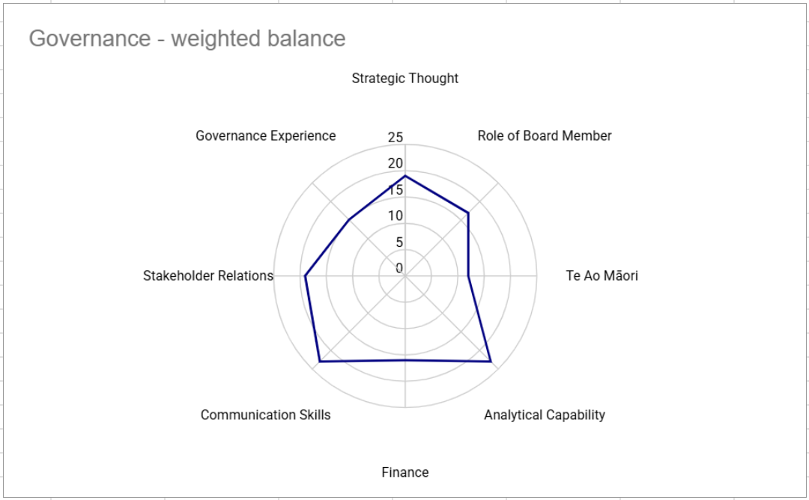

Governance skills/experience

Strategic thinking | Ability to consider issues in the context of InternetNZ’s strategic goals. Maintains a high-level perspective, weighs options objectively, and approaches decisions with an open mind.
Role of the Board Member | Clear understanding of the Board’s governance function and the value it brings. Awareness of the responsibilities and obligations placed on Board members.
Analytical capability | Applies a structured approach to problem-solving and critical reasoning. Can analyse information effectively and ask thoughtful, relevant questions.
Financial literacy | Can read and understand financial statements and reports provided to the Board. Financial knowledge meets the legal expectations placed on directors.
Communication skills | Ability to express ideas and viewpoints clearly, constructively, and with respect for others.
Stakeholder engagement | Understands the needs of InternetNZ’s stakeholders and can build and maintain constructive relationships as required.
Governance experience | Has previous experience in governance roles relevant to InternetNZ’s context.
Te Ao Māori | Awareness of Te Ao Māori in relation to InternetNZ’s role. This includes knowledge of indigenous governance, Te Tiriti o Waitangi, Māori data sovereignty, cultural competency of staff and governors, and familiarity with Tikanga Māori and Te Reo Māori. Diverse representation at the Board table is valued.

Specialist areas
While these skills often sit within the staff team, it is valuable to have them represented at the Board table as well. The key attribute is a sound understanding of, or a willingness to learn about, InternetNZ’s work and business context.

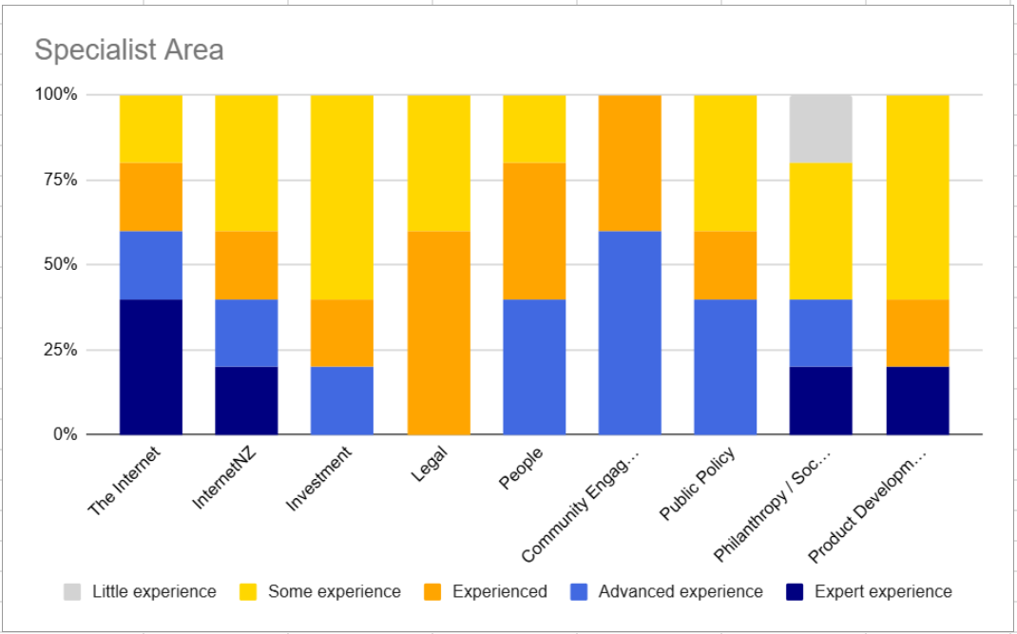

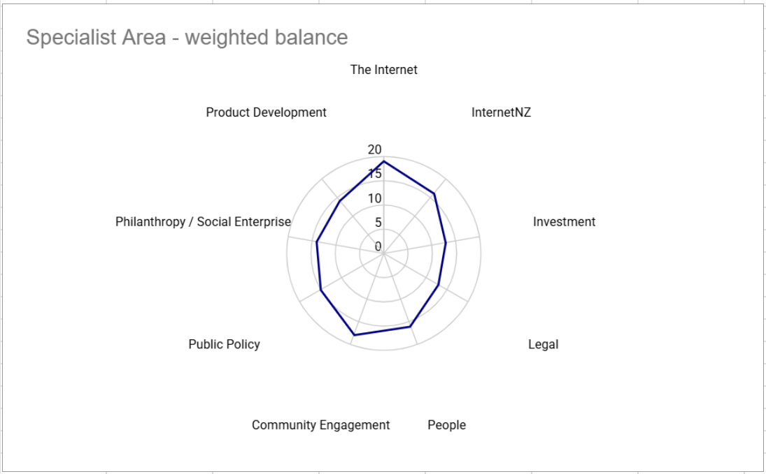

Specialist skills/experience

The Internet | An understanding of the critical role the Internet plays in society today and into the future.
InternetNZ | Familiarity with the specific role InternetNZ plays in the internet ecosystem.
Investment | Knowledge of investment principles, practices, and frameworks. Ability to work alongside management to evaluate and support appropriate investment strategies.
Legal | Understanding of legal issues relevant to the internet and the broader legal environment that impacts InternetNZ.
People and leadership | Experience in evaluating the performance of a Chief Executive, along with knowledge of human resource management, organisational culture, and staff reward and recognition practices.
Community engagement | Strong reputation and networks in the community, including with relevant industry groups, consumers, or business organisations. Ability to effectively engage and communicate with these stakeholders
Public policy | Understanding of how public policy is developed and how it impacts the internet.
Philanthropy / social enterprise | Knowledge of grant-making processes and experience in optimising the impact of philanthropic funding.
Product development, innovation and commercialisation | Understanding of current drivers of technological innovation. Experience in delivering and launching new products or services in response to market demand or opportunities for innovation and growth.

Diversity attributes
InternetNZ is strongly committed to broad representation at the Board table that reflects the diversity of the communities we serve. We value the inclusion of diverse perspectives in our governance and decision-making.
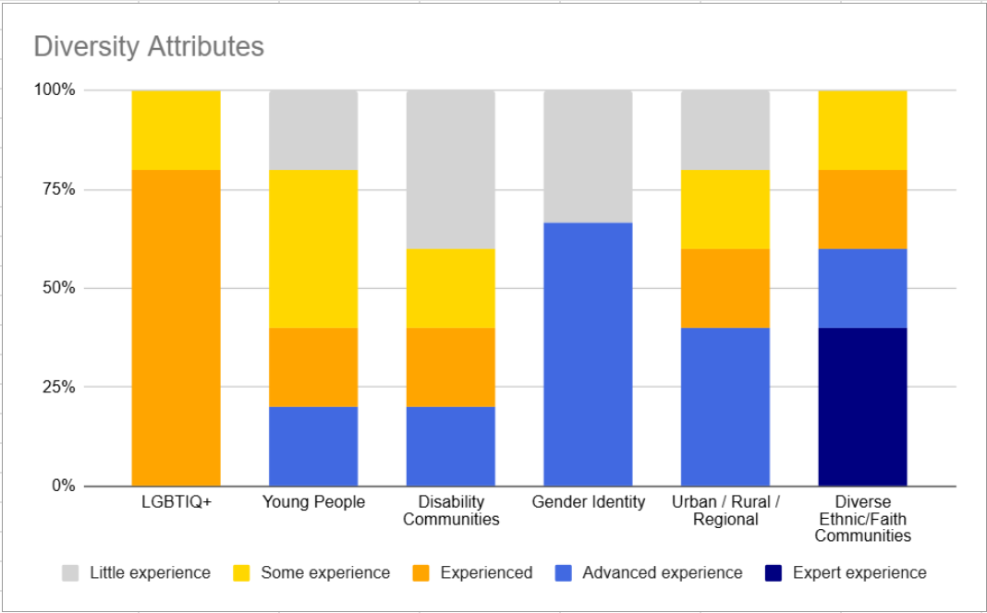
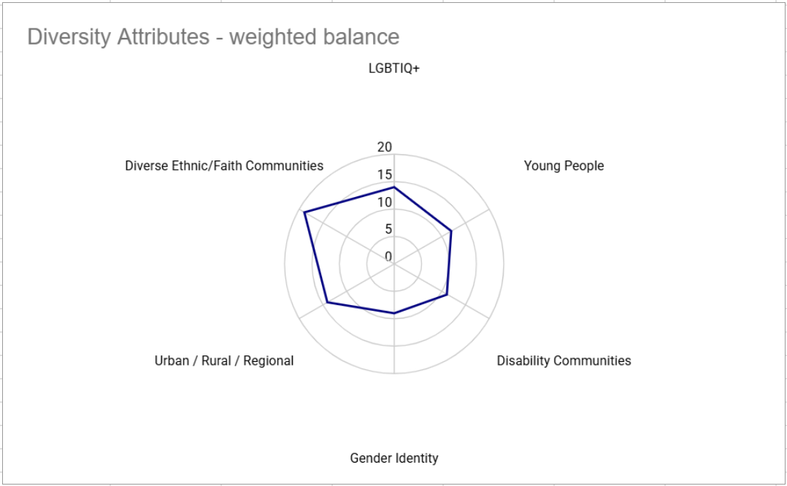

Diversity Attributes

LGBTQIA+ | Awareness of the issues and experiences of Rainbow communities, and how the opportunities and challenges relate to our InternetNZ’s work and priorities.
Young people | Younger generations are shaping the internet sector. We encourage their representation and perspectives in our governance.
Disability communities | Understanding of the experiences, barriers, and opportunities faced by people living with disability, and how these intersect with our work.
Gender identity | Awareness of the issues affecting people of diverse gender identities, and the relevance of those experiences to InternetNZ’s work.
Urban/rural/ regional | We value diverse geographic representation from across Aotearoa New Zealand — including urban centres, regional towns, and rural communities.
Ethnic communities | Understanding of the issues facing people from diverse ethnic backgrounds, and how the opportunities and challenges relate to our work.

