Helping people access and use quality evidence

Evaluating digital inclusion initiatives
  - Guidance document
August 2021

Contents
Contents i
Introduction 1
Theory of change or logic model 1
Evaluation questions 4
Indicators 4
Data collection 6
Communicating findings 8
Other resources 9
Digital inclusion 9
Evaluation websites and resources 9
Data collection methods 10
Glossary 11

Introduction
The purpose of evaluations is to generate evidence that proves how successful an initiative has been in achieving its set goals. It may also reveal areas where the initiative can be improved to become even more successful, or provide valuable learnings for similar future initiatives on what works well and what doesn’t.
In the context of digital inclusion, there is currently very little existing evidence on whether initiatives designed to improve digital inclusion in New Zealand are working or not. This situation makes it difficult to decide how to best invest in digital inclusion and identify opportunities for improvement. Hence building a body of evidence is vital to effectively advancing digital inclusion in New Zealand.
This guidance document is part of a toolkit developed by Standard of Proof in collaboration with InternetNZ to support evaluations of digital inclusion initiatives. It aims to build evaluative capability within the digital inclusion ecosystem. In particular for charitable, non-government organisations who have received funding to deliver projects or programmes to combat the digital divide.
Guidance in this document focuses on key elements for designing an evaluation. Through a step-by-step approach, each element is explained in a separate section and includes:
- Theory of change or logic model
- Evaluation questions
- Indicators
- Data collection
- Communicating findings
The document ends with a list of other available resources and further readings.

Theory of change or logic model
A first step to an evaluation is to identify what the initiative aims to achieve and how. Is the initiative supposed to bring about change and impact the lives of the specific group of people it targets? Outlining the expected chain of causes and effects leading to the intended outcomes and the activities and resources required to get there can help not only with evaluating the initiative but also with its planning, management and communication.
Developing a theory of change or logic model (the terms ‘theory of change’ or ‘logic model’ are often used interchangeably) is to create a graphical overview of the relationships between the initiative’s activities and its intended effects. Such relationships are based on assumptions, which also need to be stated to disclose the logic behind the theory. This is important because it allows a way to reflect and revise the theory of change or logic model as new evidence or lessons learned become available or as context, resources, activities or expectations change.
Regardless of the development stage of the initiative, a theory of change or logic model is considered a minimum requirement for evaluations with the aim of creating a robust body of evidence. They are usually structured around the following components and order:
- Inputs (What resources will be used to conduct the initiative? e.g. money, staff, equipment)
- Activities (What will the initiative do with its resources to direct the course of change? e.g. offering training, development of materials)
- Outputs (What will be produced through the activities? e.g. people received training, materials have been produced)
- Short/medium/long-term outcomes (What benefits have resulted from the initiative in the short/medium/long term? e.g. people gained knowledge/skills/confidence, produced materials are being used, improved system, improved wellbeing)
[NOTE: There are a variety of terms used to refer to the same components. For example, outcomes are sometimes called ‘benefits’.]
In the case of digital inclusion initiatives funded by InternetNZ, outcomes (either short, medium or long term) should include improvements of at least one of the four criteria for digital inclusion: motivation, access, skills, and trust.
A typical structure for a logic model can be found in the figure below.

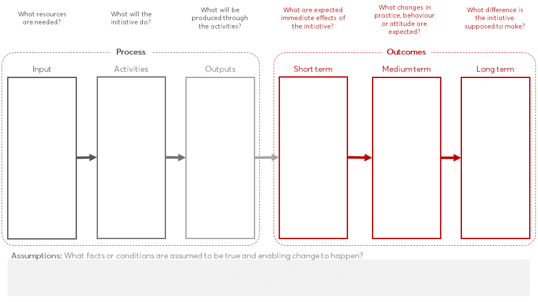
Figure 1: Example logic model template

Evaluation questions
Based on the logic model, the key question(s) can be identified that the evaluation should answer. This requires a clear understanding and definition of the scope of the evaluation. There may also be different people or groups of people who are involved in the initiative and have an interest in it. Knowing who these stakeholders are and what their priorities and information needs are is key to defining the purpose of the evaluation. The key evaluation questions determine the focus of the evaluation and need to be reflective of its purpose.
For evaluations of InternetNZ funded digital inclusion initiatives, InternetNZ as the funding agency is a key stakeholder with specific interests in the evaluation. Although every initiative will be unique, one common purpose for the evaluation is to inform InternetNZ about how effective the initiative has been in achieving its goals and how well its implementation was delivered to plan.
Against this background and based on the intended outcomes of the initiative, guiding key evaluation questions are:
- How well has the initiative been implemented?
- To what extent has the initiative achieved its intended outcome(s)?
- How is the initiative contributing to digital inclusion in New Zealand?
Depending on the individual context of an initiative, questions may need to be adjusted.

Indicators
The logic model discloses what the evaluation needs to focus on for assessing the success of the initiative. The next tool in the toolkit is the identification of indicators, which are clues, signs or markers that make outcomes measurable. Examples of indicators for digital inclusion elements (motivation, access, skills, and trust) have been provided by the Department of Internal Affairs’ Digital Inclusion Outcomes Framework and are listed in the table below.

Table 1: Indicators identified in Digital Inclusion Outcomes Framework
Outcome themes | Indicators
skills | Percentage of people with foundational digital skills  Percentage of people with communication skills  Percentage of people with handling information and content skills  Percentage of people with digital transaction skills  Percentage of people with problem-solving skills  Percentage of people who are safe and legal online
trust | Percentage of people who can confidently do all that they want to do online  Percentage of people who understand what steps to take if they face significant challenges (for example, losing their password or their password is stolen)  Percentage of people who retain the same level of confidence on the internet after facing significant challenges (for example, losing their password or their password is stolen)
access | Percentage of people who have access to an internet-enabled device  Percentage of people who can mostly connect to the internet when they want to  Percentage of people who say that the affordability of a device or connection cost is a significant reason why they do not access the internet  Percentage of people who find the content and services they need on the internet are accessible  Percentage of people who say that their internet connection has reasonable speed and remains constant
motivation | Percentage of people who see value in using the internet  Percentage of people who are aware of a range of information and activities that are valuable to them on the internet

Indicator examples in this list can be adopted if suitable for the initiative or serve as a guide in identifying other indicators.
However, identifying indicators is only half the story as every measure requires data to be measurable regardless. Data can be anything from numbers to words, observations or descriptions of things. It can be sourced through existing databases or collecting new data. The next section has more information about data collection. The table below can be used as a template to map indicators and measure how to get the required data for each outcome.
Table 2: Example indicator table template
Outcomes | Indicator | Measure | Method/  data source | Cost

Data collection
Data collection is the process of gathering and measuring information on relevant aspects of the initiative identified in the logic model. The aim is to collect the right kind of good quality data that enables answering the evaluation questions and evaluating outcomes of the initiative.
Data collection requires planning. This planning should be guided by the following three questions.
- Who will be collecting the data?
- How will the data be collected?
- How often will the data be collected?
The first question is to ensure someone is assigned to the task and there is capacity to conduct the data collection when required.
The second question involves decisions on the types of methodology to be used (qualitative and/or quantitative), instruments (e.g. interviews, surveys or questionnaires, observations, focus groups), format (e.g. paper form vs online survey) and sample (who is supposed to participate?). How data is collected is key to any evaluation and should be well thought through.
The third question addresses the planning of the different data collection timepoints. There should be at least two timepoints, before or at the start of the initiative and at the end of it. If data is only collected at the end of the initiative, there won’t be data to measure any changes against. Therefore, ideally it is crucial to collect baseline data before the start of the initiative. It is recommended to add additional data collection time points during the initiative and after it is complete (e.g. 6 or 12 months after) to test whether the effects of the initiative could be maintained.

Surveys
While surveys are a widely used instrument in research and evaluation, they require careful planning. There are several factors that need to be considered to make a survey valuable. These include:
- the survey design (e.g. the time and effort it takes for respondents to complete a survey, number of points on the rating scale, phrasing of points, order of questions and layout, etc.)
- the sample size and representativeness
- the response rate.
Response rates are key to conducting a survey. Response rates refer to the proportion of people who responded (i.e. completed the survey) out of the total number of people who have been contacted. The higher the response rate the more accurate the evaluation findings will be.
A survey template for digital inclusion initiatives is available in the UK Government’s digital inclusion evaluation toolkit.

Informed consent
Collecting data should be done in an ethical way. If people are approached for data collection they need to be informed about the purpose and use of the evaluation and freely consent to take part beforehand.
Information sheets and consent forms for participants to sign are commonly used in evaluations. A consent form gives written permission that they understand the terms of the data collection activity that will be performed. When agreeing to consent, it must be done so voluntarily and with a competent mind. If someone decides to refuse or revoke their consent at any time, this is a legitimate decision and needs to be respected.
The information sheet should include details about:
- the initiative (very brief introduction)
- the purpose of the evaluation (why it is being done)
- the activity or activities the evaluation involves (what will be done)
- the principle of voluntary participation
- privacy statement (confidentiality)
- the people conducting the evaluation and at least one contact in case participants have any questions.
The consent form should include at least:
- a statement that the participant has read the information and any questions have been answered
- full name and contact(s) of the participant
- signature of the participant
- date (when form was signed).

Communicating findings
The last tool in this toolkit is the evaluation report that synthesises the process and findings of the evaluation. The evaluation is documented in a transparent way while demonstrating and communicating the initiative’s success. The report should be written with the intended audience (here, InternetNZ) in mind. It is also advisable to add a brief summary of all the evaluation aspects in the report (initiative description, evaluation questions, design description, key findings and next steps) at the beginning.
A common structure for an evaluation report is:
- Executive summary
- Background (including a brief introduction to the initiative, the evaluation purpose, scope and design)
- Evaluation findings (with a focus on answering the evaluation questions)
- Conclusion
- Next steps
- Any relevant appendices (such as measurement tools).

Reports are not the only way to communicate the findings of an evaluation. Other forms of communication, such as workshops or presentations, may offer a platform for discussions and can be used to complement the final report.

Other resources
Other resources on digital inclusion and evaluation developed in New Zealand and internationally are available online.

Digital inclusion
The New Zealand Government has publicly available resources on digital inclusion.
https://www.digital.govt.nz/digital-government/digital-transformation/digital-inclusion/

The UK Government has published an essential digital skills framework.
https://www.gov.uk/government/publications/essential-digital-skills-framework

The digital inclusion evaluation toolkit developed for and published by the UK Government is also publicly available.
https://www.gov.uk/government/publications/digital-inclusion-evaluation-toolkit

Evaluation websites and resources
The What Works website provides general information about evaluation, such as what it is and how to plan an evaluation, and provides resources you can use in the New Zealand context. https://whatworks.org.nz/

The Social Policy Evaluation and Research Unit (Superu) developed a handbook for evaluations that is publicly available.
https://thehub.swa.govt.nz/resources/making-sense-of-evidence-a-guide-to-using-evidence-in-policy/

BetterEvaluation is a global collaboration aimed at improving evaluation practice and theory through co-creation, curation and sharing information. The website offers an overview of general evaluation terminology, methods and approaches.
https://www.betterevaluation.org/en

The report Digital Inclusion Outcomes Based Evaluation (2017) by Colin Rhinesmith and Angela Siefer focuses on outcomes-based evaluation and describes the challenges community-based organisations and other key stakeholders often face, while offering recommendations towards addressing shared barriers. The report is published by the Benton Foundation and is available online.
benton.org/outcomes-based-evaluation-report

The New Zealand Ministry for Foreign Affairs and Trade developed a number of evaluation plan and report templates that are publicly available.
https://www.mfat.govt.nz/en/aid-and-development/working-with-the-aid-programme/tools-and-guides-for-aid-activities/

Data collection methods
UNICEF’s Methodological Briefs series include an Overview: Data Collection and Analysis Methods in Impact Evaluation (2014)
https://www.unicef-irc.org/publications/pdf/brief_10_data_collection_analysis_eng.pdf

The evaluation toolkit developed by the Pell Institute includes an overview of data collection methods most commonly used in evalutions.
http://toolkit.pellinstitute.org/evaluation-guide/collect-data/determine-collection-method/

There are also some informative blog posts on evaluation data collection methods.
- TolaData explains and compares qualitative and quantitative data collection approaches.
https://www.toladata.com/blog/qualitative-and-quantitative-data-collection-methods-in-monitoring-and-evaluation/
- Funding for Good explain evaluation methods as the criteria for evaluating the success of a programme or project.
https://fundingforgood.org/what-are-evaluation-methods/

Glossary
Activities | Refers to how the initiative is delivered and describes what services or resources are provided through the initiative.
Assumptions | Facts or conditions that are assumed to be true and enable change to happen.
Baseline data | Initial collection of data which serves as a basis for comparison with the subsequently acquired data.
Digital inclusion | Circumstances where everyone can conveniently and confidently access and use digital devices and the internet.
Evaluation | Systematic process of assessing and judging the value, nature, character or quality of something.
Indicator | Clues, signs or markers that make outcomes measurable.
Input | The financial, human or material resources used to deliver a service or programme.
Key evaluation question | High-level questions that an evaluation is designed to answer.
Logic model | A graphic depiction presenting the relationships and assumptions between the inputs (resources), activities, outputs and outcomes of the initiative.
Long-term outcomes | Changes the initiative’s activities contribute to which take longer to achieve, or effects that lie in the future. Examples are changes in social conditions or future success in life.
Medium-term outcomes | Changes that occur as a result of the inititative’s activities but happen after the short-term outcomes. They often include changes in behaviours or attitudes.
Outcome | Intended changes that occur for beneficiaries as a result of the activities.
Outputs | Products, goods or services that are generated by the activities of the initiative. They are usually easily measurable.
Response rate | Proportion of the total population that responded to a survey.
Short-term outcomes | Immediate changes that occur in response to the initiative’s activities. They often include changes in awareness or knowledge, or gaining new skills.
Stakeholder | A person or group with a vital interest in the initiative.
Target population | A group of people in society who share a specific characteristic (e.g. age, gender, live in rural areas, etc.) that the initiative is focusing on.

Department of Internal Affairs. 2019. Evaluating digital inclusion initiatives: How can we get better evidence for what works? Wellington: Department of Internal Affairs.
superu. 2017. An evidence rating scale for New Zealand.
Department of Internal Affairs. 2019. The Digital Inclusion Blueprint, Te Mahere mō te Whakaurunga Matihiko. Wellington: Department of Internal Affairs.

