Research report

.nz consumers and businesses research

SUMMARY REPORT

November 2025

.nz is still New Zealand’s preferred and most trusted domain name, but AI is changing businesses’ digital presence and raising consumer expectations.
InternetNZ surveyed consumers and businesses in Aotearoa in August 2025. We asked about their online presence, domain name use, and how their online behaviours have changed over the past two years. We last conducted this research in 2022, so the new survey results reveal some interesting changes.
Perception gaps we saw in 2022 between how businesses and consumers view online channels continue to present an opportunity for organisations wanting to close the gap. There has also been an exponential increase in the use of AI, changing businesses’ online presence and the ways consumers interact with businesses.
Unchanged from previous years, both businesses and consumers place high value on domain names as a way to individualise their online presence. .nz remains the most preferred domain name choice because it emphasises businesses’ local NZ identity and communicates trust and credibility.

About the research
The survey is designed to provide insight into how Aotearoa businesses and consumers are using domain names and their thoughts around different types of domain names.
Total of 500 consumers answered the survey online. Representative of New Zealand population 18 years+ by age, gender, ethnicity and location. Margin of error on results +/-4.4%.
Total of 750 businesses answered the survey online. Providing a cross section of New Zealand’s business landscape by region and size. Margin of error on results +/-3.6%.
Online survey conducted:
- 2025 – 31 July to 21 August
- 2022 – 5 April to 10 May
- 2020 – 29 October to 20 November

Online presence and digital touchpoints
Businesses continue to rate websites as the most important digital channel for their success.
Despite this knowledge, little more than half (53%) of businesses have a website, the same proportion as in the 2022 survey. But 61 percent rank it was the most important digital tool for a business’s success.
ONLINE PRESENCE A BUSINESS CURRENTLY HAS, VS WHAT THEY THINK IS IMPORTANT TO HAVE
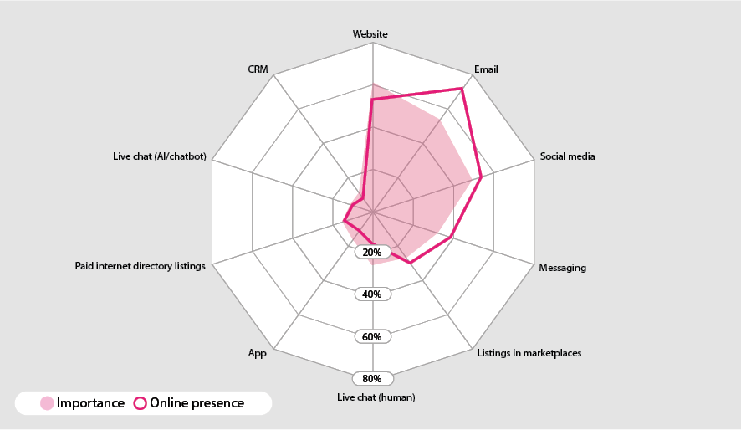

Businesses rate email second most important.
Use of email, although showing signs of a decline, continues to be higher than its perceived importance. This year we asked businesses about messaging and live chat and the high use of these channels suggests they are starting to replace email when it comes to interacting with consumers.

THE DIGITAL TOUCHPOINTS BUSINESSES RANK AS MOST IMPORTANT TO SUCCESS
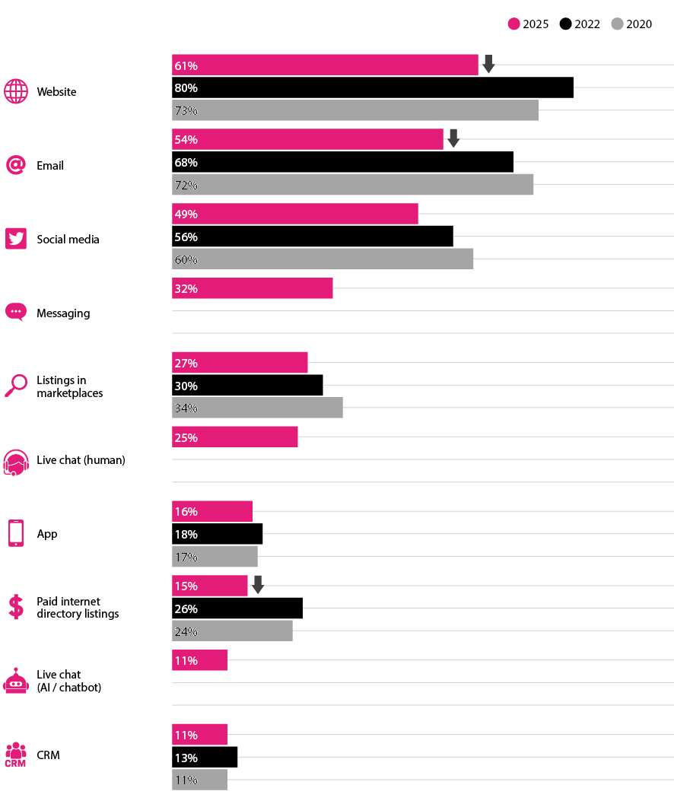

Changes in online presence
Over the past two years, businesses report the main changes in their online presence has been an increase in social media engagement, enhanced websites, and increased e-commerce capabilities, driven partly by AI.
Main changes in businesses’ online presence
- Increased social media activity
Businesses are posting more frequently, creating video content (especially short-form videos and reels), and engaging more with their audiences.
“Over the past two years, I’ve really focused on improving my online presence by being more active on social media platforms like Instagram and Twitter, where I share updates, engage with followers, and offer more behind-the-scenes content.”
- Website improvements
Upgrading of websites, focusing on better functionality, mobile optimisation, improved navigation, and enhanced e-commerce features.
“We launched a redesigned, mobile-friendly website with improved navigation and e-commerce functionality, making it easier for customers to browse and purchase our products online.”
- AI integration
Increased use of AI tools such as AI chatbots for customer service, content creation, and streamlining of operations with AI-driven solutions.
“Since implementing AI, we’ve noticed customers interacting with our business in faster, more streamlined ways. Many now use our AI-powered chat support instead of traditional email or phone calls.”

Impact of AI
68% of businesses surveyed said they are using AI.
AI integration largely focused on using tools that save time, automate customer support, and enhance marketing personalisation.
USE OF AI BY BUSINESS
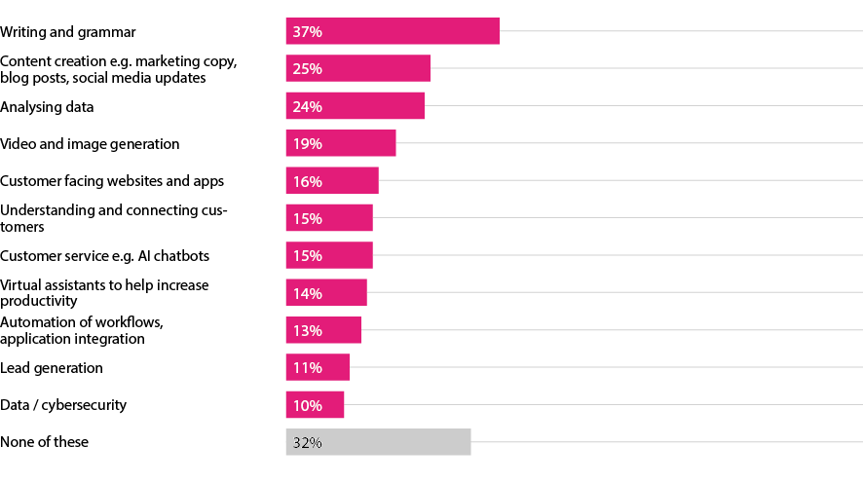
“Since implementing AI, customers now talk to our chatbot more, find answers themselves, and get quicker, more personal replies.”
“We use AI tools to generate high-quality social media posts, captions, and product descriptions.”
“AI-driven tools personalise customer experiences and deliver targeted product recommendations.”
AI helps us predict trends, optimise ad campaigns, and refine content strategies for maximum impact.”
With AI’s growing presence, businesses are noticing consumers are demanding faster, more personalised interactions, and are increasingly using self-service tools.

Things customers are doing differently as a result of ai
- Increased use of AI powered tools for self-service: “We’ve seen an increase in customers self-serving through our AI-driven FAQs and support tools.”
- Higher expectation of speed and efficiency: “Customers seem to expect quicker responses because AI provides instant feedback elsewhere.”
- Demand for more personalised experiences: “They want personalised offers, making interactions more tailored and relevant.”
- Increased after-hours engagement: “There’s an increase in after-hours engagement since AI tools are available 24/7.”

Role of digital channels

Online channels are perceived to fulfil different roles for business.
According to businesses surveyed, email is most effective for one-to-one contact with customers, websites for demonstrating professionalism and credibility, and social media for reaching new audiences.

MAIN BENEFITS OF WEBSITES, EMAIL AND SOCIAL MEDIA AS PERCEIVED BY BUSINESSES IN 2025
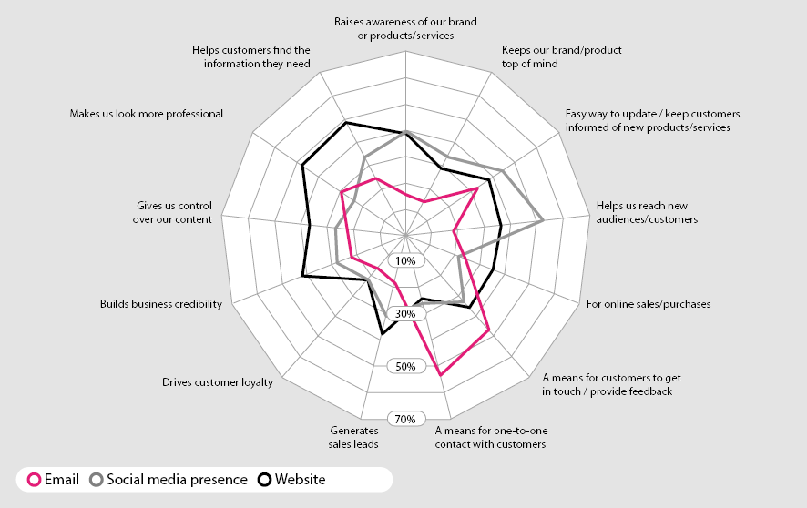

The perceived benefits of websites continue to grow over time.
Perceived benefits have strengthened most in terms of professionalism, control, and helping customers find the information they need.
MAIN BENEFITS OF WEBSITES OVER TIME
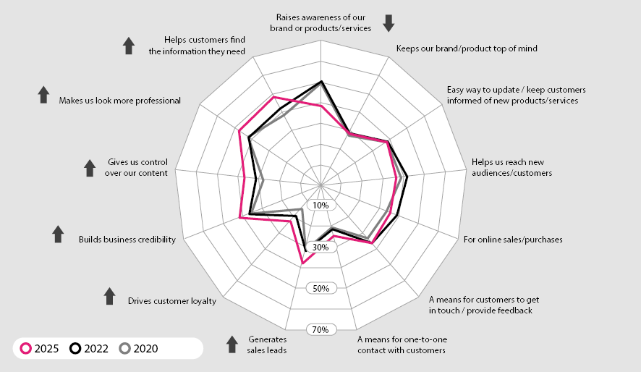

Mismatch in perceptions

Comparing businesses to consumers, a mismatch in perceptions of the main benefits of digital touchpoints persists.
While a little over a third of businesses see websites as a way to make sales, more than half of consumers think that’s the primary benefit of a website.
There’s a similar perception gap for email – businesses see its benefit as a means for one-to-one contact, but customers see it as a way for a business to keep them updated.
MAIN BENEFITS OF WEBSITES (LEFT), MAIN BENEFITS OF EMAIL (RIGHT)
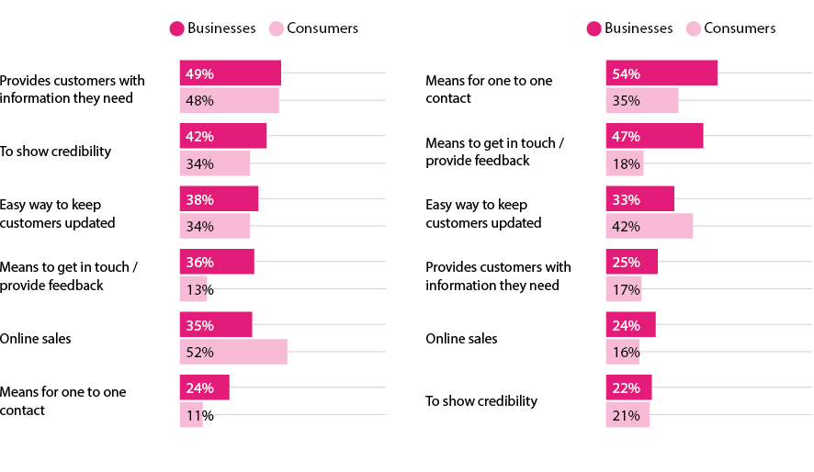Businesses may be overestimating the benefits of social media, with consumers ranking its benefits lower than businesses do.
Although businesses and consumers perceptions of the benefits of messaging are largely aligned, businesses still rank its benefits higher than consumers do.

MAIN BENEFITS OF SOCIAL (LEFT), MAIN BENEFITS OF MESSAGING (RIGHT)
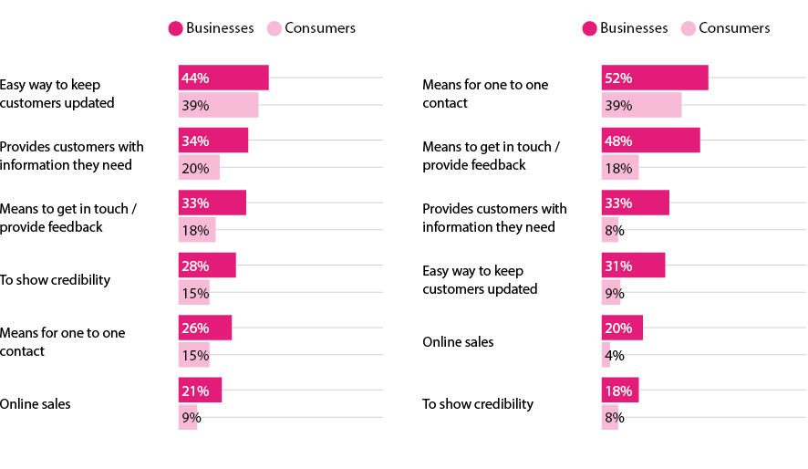
Both consumers and businesses see a live chat (with a human) a good means for one-to-one contact but businesses rather its importance higher.
A live AI chat (chatbot) is perceived by some businesses as a means for sales, but very few consumers see it that way.
MAIN BENEFITS OF LIVE CHAT WITH HUMAN (LEFT), MAIN BENEFITS OF LIVE AI CHAT (RIGHT)
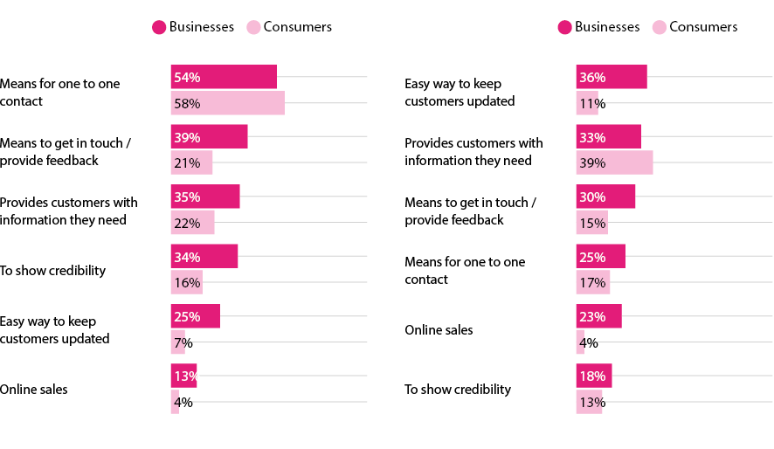

Which digital channels do you regularly use?
While use of live chats to engage with businesses is apparent in these survey results, both with humans and AI, there is a generational difference in their use.
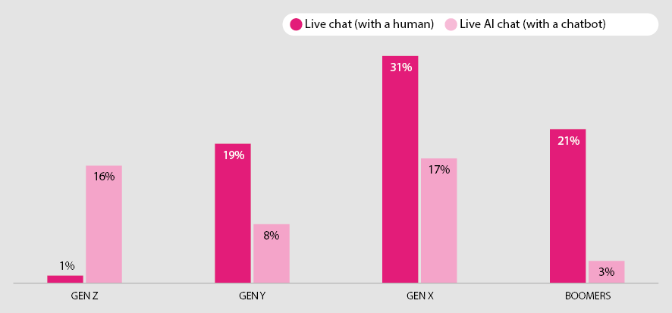

Domain name awareness and use
Awareness of what a domain name is has increased among businesses, reaching 92%, and has returned to 2020 (pre-Covid) levels among consumers.
DOMAIN NAME AWARENESS
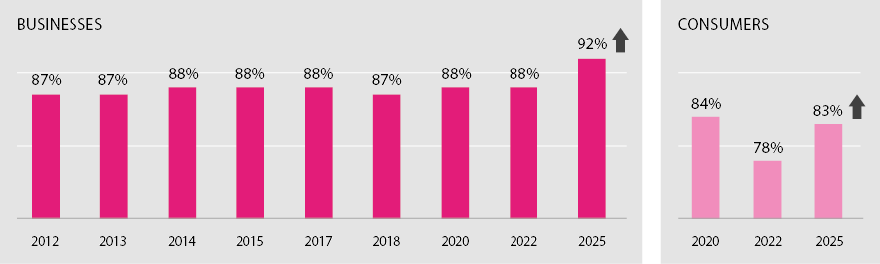
Note: Pre-2022 figures from other sources.

Domain name ownership has remained stable.
In line with 2022 survey results, 6 in 10 businesses and around a fifth of consumers have a domain name.
The most common use of domain names among businesses continues to be for a website followed by email address. Among consumers, domain names are mainly used for email, with this use showing an increase from 3 years ago.

DOMAIN NAME OWNERSHIP
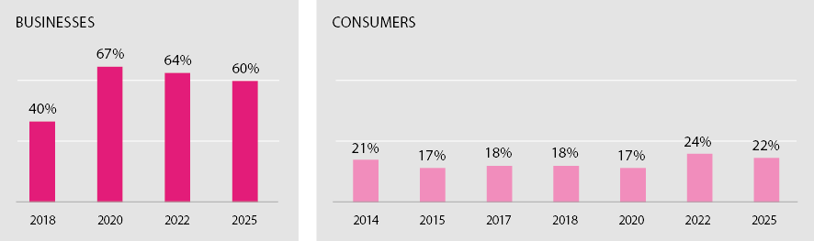
MAIN USES OF DOMAIN NAMES
Businesses (left), Consumers (Right)
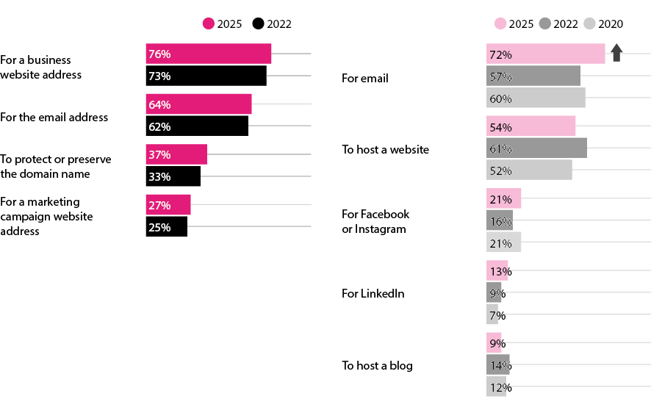

Domain name set up
Nearly half of businesses (47 percent, up five percentage points from 2022) set up their domain name without assistance. Eighty-three percent said it was somewhat or very easy to do, up seven percentage points from 2022.

EASE OF SETING UP A DOMAIN NAME
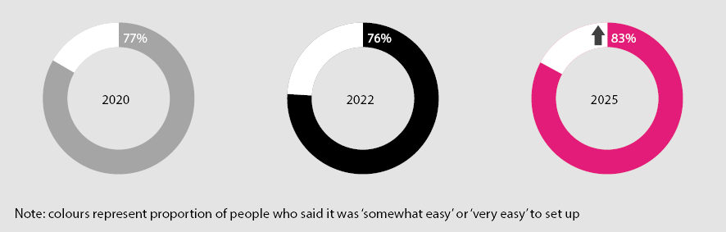
Around one in 10 used AI to help them through the domain name registration process, and close to two in 10 used it to come up with a domain name.
USE OF AI TO HELP SET UP A DOMAIN NAME
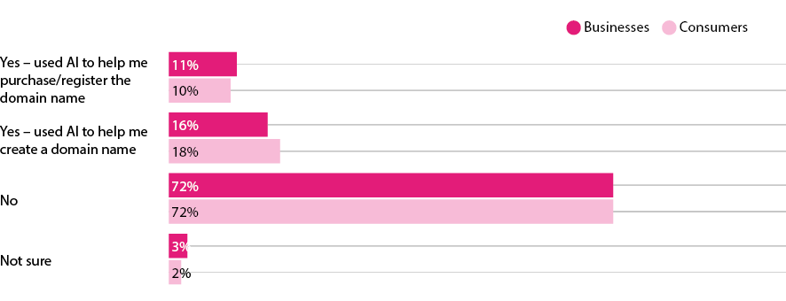

.nz domain names
Seven out of every 10 businesses surveyed with a website have a .nz domain name. It’s slightly lower for individuals with a website.
Among businesses the .nz share of domains remains steady. But among individuals it has dropped, with more than half now having a .com.
TYPE OF DOMAIN NAME USE/OWN
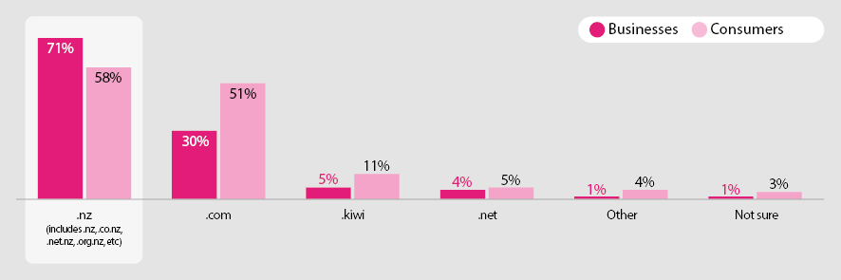

Top reasons for choosing a .nz domain name
Businesses
- Clearly signals a NZ business
- Helps build trust and credibility with local customers
- Aligns with NZers wanting to support local/NZ businesses
- Differentiation from international competitors
“I chose a .nz domain name for our business to clearly establish our local presence and credibility in New Zealand.”
“It helps build trust and credibility with local customers.”
Consumers
- Shows connection to NZ
- Trust due to link to NZ
- Improved search results in NZ
- Most suitable/relevant for NZ businesses
- Availability of desired name
“I chose a .nz domain name because it represents New Zealand, helping to show that the website is based in or connected to New Zealand.”
“It also builds trust with local users and can improve search results for people in New Zealand.”

Perceptions of .nz
Brand image perceptions of .nz are consistent among businesses and consumers, but with .nz brand awareness stronger among businesses overall.
.NZ BRAND ASSOCATION
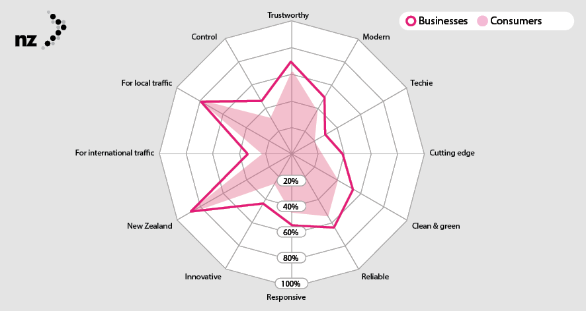
Agreement that .nz is more trustworthy than other domain names shows an increasing trend over time among businesses (up from 58% in 2020 to 74% in 2025).

AGREEMENT .NZ IS MORE TRUSTHWORTHY
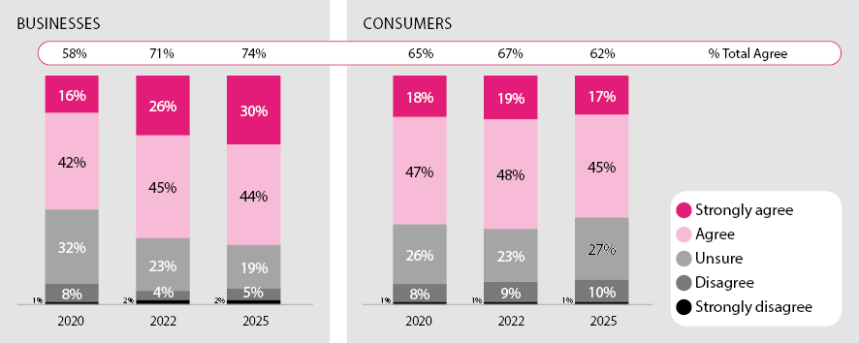

AGREEMENT .NZ OFFERS MORE VALUE
